|  |  |
| --- | --- |
| Week | Topics |
| 1 | Revision |
| 2. | Importance of Computer as a processing tool |
| 3. | Devices |
| 4. | Types of computer |
| 5 | Uses of the computer |
| 6. | Advantages and disadvantages of computer |
| 7and 8 | Types of computer keyboard |
| 9. | Pointing devices |
| 10. | The mouse |
| 11. | Revision |
|  |  |

Scheme of work for 3RD TERM

WEEK 1 REVISION

**Computer Processing**

Computer processing is an action or series of actions that a microprocessor, also known as a central processing unit (CPU), in a computer performs when it receives information. The CPU is a type of electronic “brain” for a computer system, and it executes a series of instructions that are fed to it by software programs installed onto a computer’s hard drive and loaded into random access memory (RAM). Though modern computer systems have become much faster and more complex than their earlier counterparts, they still perform the same basic type of computer processing.

**WEEK 2**

**Topic Importance of Computer as a Tool For Processing Data**Computer is the most powerful machine in today's world. It has become the need in everyone's life. A computer can perform task very quickly and accurately. Computer has its own features and characteristics.

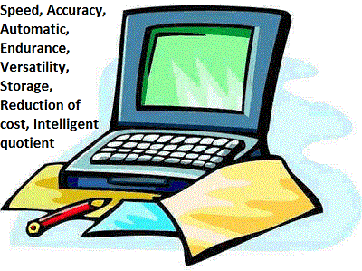

**Some of the important characteristics of computer as a tool for processing are described below:**

**Speed**

The data processed using computer system is done at a very fast rate which other machine cannot.Speed of computer maybe defined as the time taken by a computer to perform a task. It takes only a few seconds for the calculations that we take hours to solve. Its speed is measured in term of MHZ (Mega Hertz).

**Accuracy**

The computers are the accurate machine that can perform large number of tasks without errors, but if we feed wrong data to the computer it returns the same wrong information called GIGO (Garbage In Garbage Out).

**Reliability**: Computers are the most reliable machine that has ever Exist in human history therefore any information obtained from computer processed data is highly reliable.

**Diligence**

The capacity of computer of performing repetitive task without getting tired is called diligence. A computer is free from tiredness, lack of concentration, fatigue etc therefore it can work for hours without creating any errors.

**Versatility**

The capacity of computer of performing more than one task at the same time is called versatility of computer. Versatility means the capacity to perform different types of work completely.

**Storage**

Computer has mass storage section where we can store large volume of date for future use. Such data are easily accessible when needed. Magnetic disk, magnetic tape and optical disk are used as mass storage devices

**Automatic**

Computer is an automatic machine which works without the intervention of the user. The user is required to give the data and utilize the result but the process is automatic.



**WEEK 3**

**Device**

In general, a device is a machine designed for a purpose. A computer can be considered a device.

In the context of computer technology, a device is a unit of hardware, that is capable of providing input to the essential computer, receiving output or even performing both input and output operation. *Computer devices* can be referred to as hardware components such as: keyboards, mouse, display monitors, hard disk drives, CD-ROM players, printers, audio speakers and microphones, and other hardware units.

Peripherals are sometimes used as synonyms for *devices* or any input/output unit.

**Class of devices**

1. **Mechanical devices :**

A **machine** is a tool containing one or more parts that uses energy to perform an intended action. Machines are usually powered by mechanical means. An example of mechanical device is a Generating set.

1. **Electrical device :**

A device that produces electricity or powered by electricity. **Electrical** circuit devices have no decision making capability: Example is an electric Iron

1. **Electronic Device :**

This is a device that accomplishes its purpose electronically with the capability of making decisions. These include lightweight consumer electronic device that looks like a hand-held computer which has operational capabilities.

Top of Form

Bottom of Form

**Early counting Device**

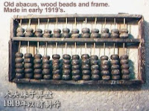**Abacus**   
The earliest counting device. It was invented so many years ago.

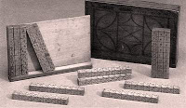**Napier’s bones**  
Invented by John Napier In 1614

**Slide Rule**  
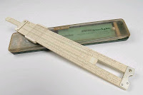In 1620, William Oughtred developed a device called slide rule.

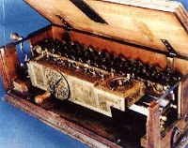**Leibniz's Calculating Machine**  
Gottfried Leibniz,In 1671 he developed a machine which is also called Stepped Reckoner.

**Analytical Engine**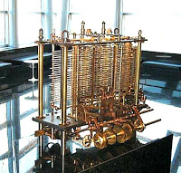  
Charles Babbage developed a machine called Analytical Engine in 1833. He is the *Father of Computer Science*.  
  
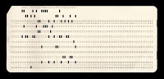**Punched Card**  
Dr. Herman Hollerith developed punched cards to solve the problem in American census in the year 1886-1887

EXERCISE

1. Define Device

2. State the classes of devices

**WEEK 4**

**TYPES OF COMPUTER**

There are three basic kinds of computers. The following are the three types.

**Digital Computer**

a computer that processes information in digital form. They convert the data into digits (binary digits 0 and 1) and all operations are carried out on these digits at extremely fast rates. Digital Computers are much faster than analog computers and far more accurate. Computers used for business and scientific applications are digital computers.

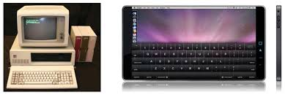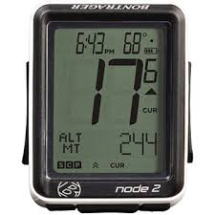

**Analog Computer**

A computer that represents data by measurable quantities in order to solve a problem, rather than by expressing the data as numbers. Computations are carried out with physical quantities such as voltage, length, current, temperature etc. for example voltmeter, Speedometer, ammeter. Analog computers operate by measuring rather than counting, but accuracy is poor. An electronic weighing scale is an example of an analog computer.

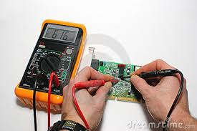

**Hybrid Computer**

Hybrid computers utilize the best qualities of both the digital and analog computers. In these computers some calculations take place in analog manner and rest of them take place in digital manner. Hybrid computers are best used in hospital where analog part is responsible for measurement of patient’s heart beat, blood pressure, and then the operation is carried out in digital fashion to monitor patient’s vital sign. Hybrid computers are also used in weather forecasting.

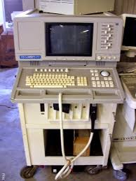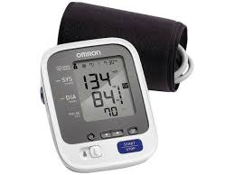

**EXERCISE**

**State and explain the three types of computer**

**WEEK FIVE**

**COMPUTER USES**

The computer can be used in different fields such as

**Internet**

The computer helps people to connect with other computer users worldwide. One can browse through much more information over the internet than you could do in a library.

**Medicine**  
  
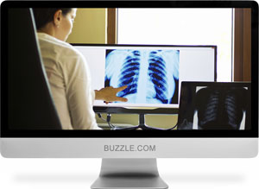With the help of computers you can diagnose disease and learn about studies related to them. Computer is used for performing surgery too. They are also used to store patient records, and other information.

**Banks**  
  
All financial transactions such as deposit, payments funds transfer e.t.c are done by computer software. It provides security, speed, and convenience.

**Travel**

One can book air tickets or railway tickets using the Internet, and make hotel reservations online

**Telecommunications**

Computer is widely used in telecommunication industries for overall connectivity, maintenance, engineering and monitoring of the networks. Also, all mobile phones have software in them, making it easier to handle certain tasks.

**Defense**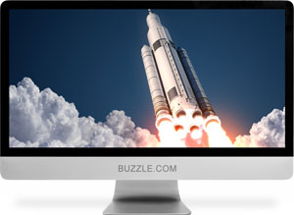  
Computers are used in the military with Software embedded in almost every weapon, such as in controlling flight and targeting, in ballistic missiles.

**School E-Learning**  
 Instead of studying from textbooks, computers make it easier to learn from an e-learning software. These are available electronically online, and are accessible either freely or through a course that one pays for

**Examinations**  
You can take online exams and get instant results. You can also check your examination results online which saves one from a lot of hassles

**Business**Shops and supermarkets use Computer software that calculates a customer's bills, as well as keeps track of how much is made monthly.

**ATMs**  
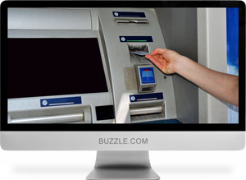 The computer software authenticates the user through his/her credit/debit card, before it dispenses cash.

**News**There are many websites through which you can read the latest news, as well as access old articles and videos related to a past event.

**Airplanes**  
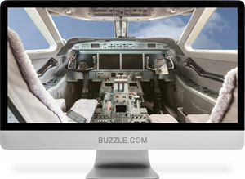Pilots train using software, which simulates a flight to help aircraft both big and small, to take off and land.

**Weather Analysis**Supercomputers are used to predict weather conditions

EXERCISE

State the uses of computer

**WEEK SIX**

**Advantages of using computers for information processing include**

|  |  |
| --- | --- |
| http://www.wong-sir.com/cit/images/adv_bullet.jpg | Tasks can be completed faster because computers work at amazing speed. |
| http://www.wong-sir.com/cit/images/adv_bullet.jpg | Computers can process large amounts of data and generate error-free results, provided that the data is entered correctly. |
| http://www.wong-sir.com/cit/images/adv_bullet.jpg | Computers can store enormous amounts of data for future use. |
|  | The high reliability of components inside modern computers enables computers to produce consistent results. |
| http://www.wong-sir.com/cit/images/adv_bullet.jpg | You can download any amount of material through computer. |
| http://www.wong-sir.com/cit/images/adv_bullet.jpg | All your arithmetical problems can be easily sorted out through computer, |
| http://www.wong-sir.com/cit/images/adv_bullet.jpg | Through video conferencing you can see each other and talk with any body living in any part of the world |
| http://www.wong-sir.com/cit/images/adv_bullet.jpg | Efficiency and productivity can be raised. |
| http://www.wong-sir.com/cit/images/adv_bullet.jpg | Running cost becomes lower in the long term. |
| http://www.wong-sir.com/cit/images/adv_bullet.jpg | Tasks can be completed with little human intervention (i.e., automatic). |
| http://www.wong-sir.com/cit/images/adv_bullet.jpg | Overall security can be raised due to less human intervention. |
| http://www.wong-sir.com/cit/images/adv_bullet.jpg | Customer services can be improved due to more efficient management and operations. |
| http://www.wong-sir.com/cit/images/adv_bullet.jpg | Computers with communicating capability can share data and information with other computers. |

Disadvantages of using computers for information processing include

|  |  |
| --- | --- |
| http://www.wong-sir.com/cit/images/disadv_bullet.jpg | Initial investment cost can be high. |
| http://www.wong-sir.com/cit/images/disadv_bullet.jpg | Extra cost is required to employ specialized staff to operate and design the data processing system. |
| http://www.wong-sir.com/cit/images/disadv_bullet.jpg | Some jobs may be lost due to computerization and thus lower the morale of staff members. |
| http://www.wong-sir.com/cit/images/disadv_bullet.jpg | Some staff has to be trained or retrained. |
| http://www.wong-sir.com/cit/images/disadv_bullet.jpg | Face-to-face interactions among staff may be reduced. |
| http://www.wong-sir.com/cit/images/disadv_bullet.jpg | Makes you vulnerable to cyber crimes  One can be laud into cybercrimes or even be a victim |
| http://www.wong-sir.com/cit/images/disadv_bullet.jpg | Too much use of the computer a student can cause ill effect on his / her education |

|  |  |
| --- | --- |
| http://www.wong-sir.com/cit/images/clip_bullet.jpg | Exercise  1. What is computer processing ?  2. State 4 advantages of using computer for information processing  3. State 4 advantages of using computer for information processing |

**Prolong Use of the computer can cause the following on our health**

1. Lack of Physical Activity cause laziness.
2. Causes poor blood circulation Due to Using computer for long hours This causes fatigue in the limbs, painful cramps and blood clots.
3. Skipping meals : While working on a computer we often tend to forget to eat and end up skipping meals.
4. Can result in overeating and obesity : Moreover prolonged sitting and no movement causes fat to accumulate inside our bodies and risk obesity.
5. Poor sitting position/Poor posture causes body-ache
6. Causes headache : Using computers for long hours can cause severe headache
7. Poor eye sight : Constantly staring at the monitor screen stresses out our eyes and makes them dry and sore.
8. Can lead to insomnia : staying awake and giving up sleep to use computer and internet could cause adverse effects to the brain and health
9. Has an ill effect on education: Students can easily access social media sites and explicit contents which are biggest distractions for the youngsters.
10. Makes you vulnerable to cyber crimes: One can be laud into cybercrimes or even be a victim.
11. An unhealthy addiction : once you have become an active user it isn’t very difficult to get caught in the addiction.
12. Results in an Inactive social life

People tend to spend more time on computer chatting with friends rather than going out and hanging out to spend time with them.

**EXERCISE**

1. State 7 advantages of the computer

2. Mention 4 disadvantages

**WEEK SEVEN AND EIGHT**

**TYPES OF COMPUTER KEYBOARDS**

1. Ergonomic Keyboard
2. Flexible Keyboard
3. Gaming Keyboard
4. Internet Keyboard
5. Laptop Keyboard
6. Laser Keyboard
7. Mini Keyboard
8. Multimedia Keyboard
9. Numeric Keyboard
10. Portable Keyboard
11. Trackball Keyboard
12. Wireless Keyboard

**Classification By Size**

Standard keyboard, laptop-size keyboard, thumb-size keyboard and numeric keyboard.

Standard keyboards are used with PC, laptop-size keyboard come with laptop, not sale alone. Thumb-size keyboard are small enough to be carried to anywhere.

**CORRECT SITTING POSITION**

How to Sit at a Computer

Sitting at a computer for long periods of time can affect your body. Here are some tips on maintaining good ergonomics and staying comfortable at your desk during the day

Steps

1

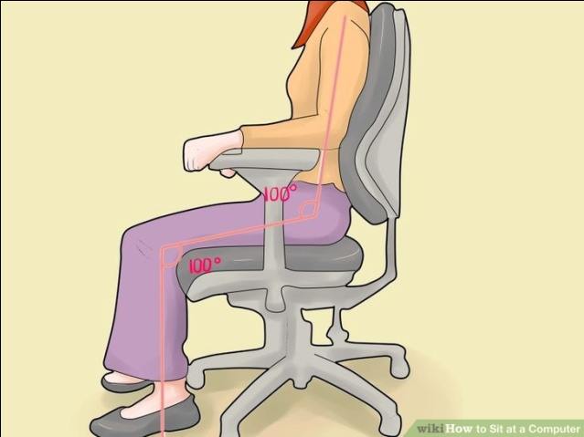Sit up tall.Push your hips as far back as they can go in the chair. Adjust the seat height so that your feet are flat on the floor and your knees equal to, or slightly lower than, your hips.

2

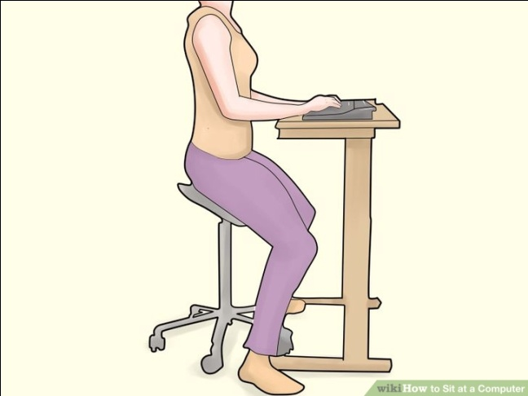Sit close to your keyboard.Position it so that it is directly in front of your body.

3

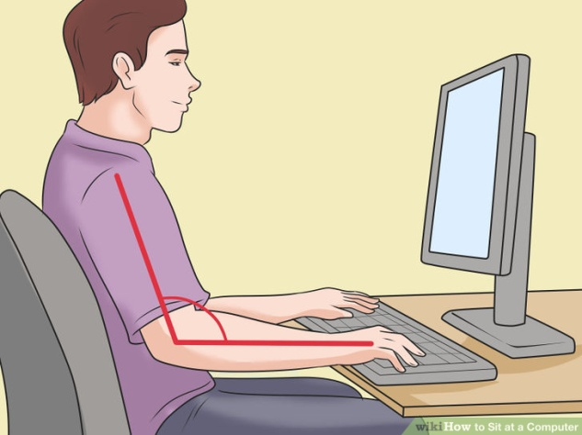Adjust the keyboard height.Make sure your shoulders are relaxed, your elbows are in a slightly open position, and your wrists and hands are straight.

4

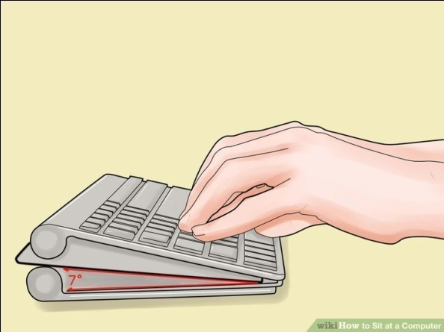Adjust the tilt of your keyboard based on your sitting position.

5

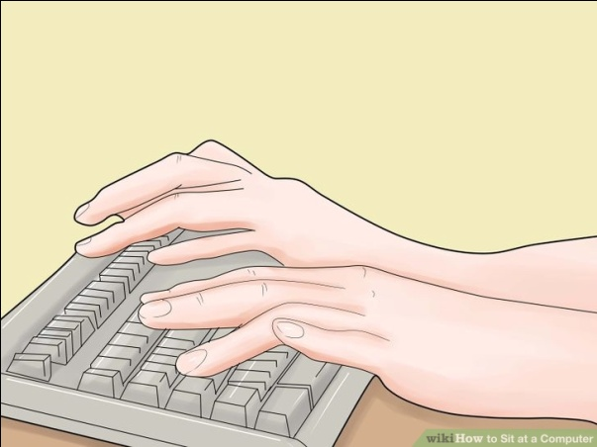Use wrist rests.They will help maintain neutral postures and pad hard surfaces

6

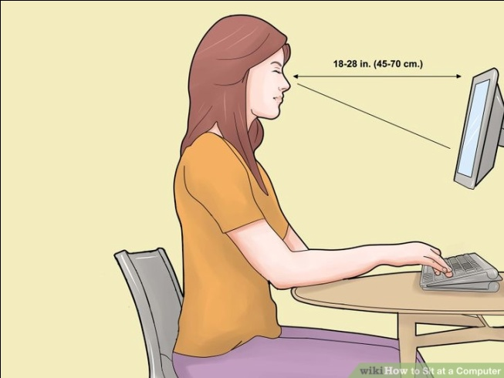Position your monitor properly. Center the monitor directly in front of you, above your keyboard.

7

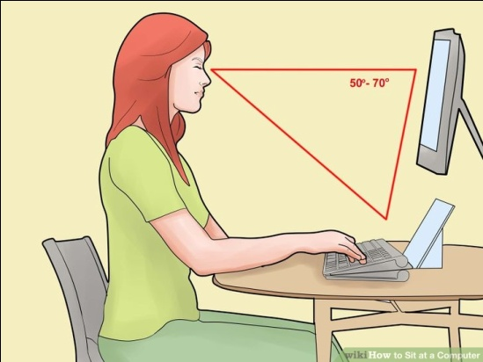Position the source documents directly in front of you.

8



Take short 1-2 minute stretchbreaks every 20-30 minutes. After each hour of work, take a break or change tasks for at least 5-10 minutes. Always try to get away from your computer during lunch breaks.

*.Avoid eye fatigue by resting and refocusing your eyes periodically.

10

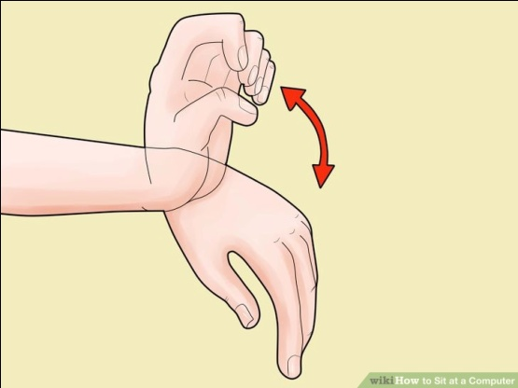Exercise your hand by pushing on top of your fingers, and using backward resistance movements.

EXSRCISE

1. Mention 5 types of keyboard

2. Describe the correct sitting position while using the computer

**WEEK NINE**

**POINTING DEVICES**

A pointer represents a small symbol on the screen. It usually appears on the screen in Graphical User Interface (GUI) environment. A pointing device is an input device. It is used to control the movement ofthe pointer or cursor on the screen. It can also be used for:

1. Sending command signals to the computer.
2. Selecting items on the screen.
3. Selecting commands from commands menu.
4. Drawing graphs etc.

**Most Important Pointing Devices**

The most important pointing devices are as follows:

1. Mouse

2. Trackball

3. Pointing Stick

4. Joystick

5. Touch Pad

6. Touch Screen

7. Light Pen

8. Digitizer/Graphic Tablet

**WEEK TEN**

**Mouse**

Mouse is the most commonly used pointing input devise. It is used to control the cursor or pointer on the screen and to give commands to the computer. It is very easy to use. The mouse is attached with the computer by a cable or wireless connection.The top of mouse contains one wheel and 2 buttons. These buttons can be clicked or double

clicked to perform different tasks.

**Two Types of Mouse**

The most popular types of mouse are as follows:

**(i) Mechanical Mouse**: It has a small ball at the bottom. The ball rotates as the mouse is rolled over a flat surface. As the mouse is rolled over the flat surface, the pointermoves in the same direction on the screen.

**(ii) Optical Mouse:** It has no ball at the bottom. It uses the laser technology to detect the mouse movement. Nowadays, it is commonly used in personal computers (PCs).

**2-Trackball**

A trackball is a pointing input device. It has move-able ball on its top. The ball is rotated or rolled with fingers (or palm of the hand) to move the pointer on the screen.

**3- Touch Pad**

Touch pad is also known as track pad. It is a small, flat surface over which a user slides fingertip to move the pointer on the screen.Touch Pad is normally used with laptops.

**4- Pointing Stick**

It looks like a pencil eraser. It exists between keys of keyboard. It is used to control the movement of a pointer on the screen and is normally used with laptop computers.

**5- Joystick**

Joystick consists of a vertical handle or hand-held stick mounted on a base. It is used to control the movement of pointer on the screen. It is basically used to play video games

**6- Touch Screen**

A touch screen is a special video display screen. Input is given to the computer directly by touching the screen with user fingertip.

**7- Light Pen**

The light pen is a hand-held pointing input device.It looks like a pen connected with the computer by a wire.Input is given to the computer directly by touching the screen with pen.

**8- Digitizer or Graphics Tablet**

Digitizer is used for drawing new images usually, it is used for making maps andengineering drawings. A digitizer is also known as graphics tablet

**Mouse Techniques**

Using the mouse involves five techniques:

1. **Pointing**:Move the mouse to move the on-screen pointer.
2. **Clicking**:Press and release the left mouse button once.
3. **Double-Clicking**:Press and release the left mouse button twice.
4. **Dragging**:Hold down the left mouse button as you move the pointer.
5. **Right-Clicking**:Press and release the right mouse button.
6. **Hover :** Move the mouse pointer over an item and let it remain there without clicking either mouse button.
7. **Ctrl – Clicking** : This technique is useful when selecting multiple files or folders
8. **Shift+clicking** : lets you select a series of contiguous files.
9. **Scrolling** : Roll the wheel away from you to scroll up, roll it towards you to scroll down.
10. **Right dragging-and-dropping** an object pops up a menu of options that let you choose whether to Copy or Move the object